43.55: Using Eq: (43.12):
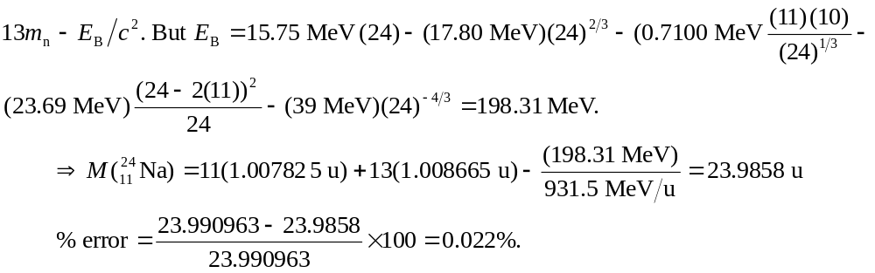
If the binding energy term is neglected,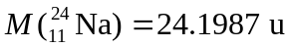and so the percentage error would be 